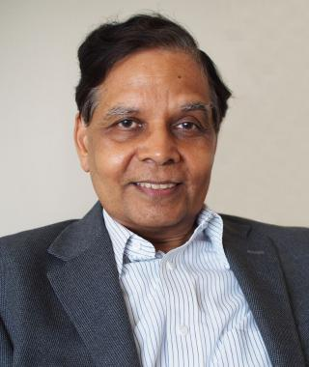
Dr. Arvind Panagariya, Director of the India Center at Columbia University
Co-Chair, NIACC Economics Academic Advisory Board
Indan PM Modi”s s Chief Economist at Niti Aayog, with cabinet rank. Professor of economics, Columbia University, vice-chairman of the government of India think-tank NITI Aayog till Aug 2017 previously Chief Economist at the Asian Development Bank worked for the World Bank, International Monetary Fund, World Trade Organization, and the United Nations Conference on Trade and Development(UNCTAD). He holds a Ph.D in economics from Princeton University.
As of 2018, Panagariya has written more than 15 books, including India: The Emerging Giant, published in March 2008. Papers written by him for the World Bank and IMF usually promote the idea of privatizing all the state owned enterprises of India. It was described as the ‘definitive book on the Indian economy’ by Fareed Zakaria. He has appeared on Bloomberg TV India for the show "Transforming India With Arvind Panagriya” On 5 Jan 2015, he was appointed Vice-Chairman of the National Institution for Transforming India Aayog, the replacement for the Planning Commission. Panagariya is also heading analysing the data of the Socio Economic and Caste Census 2011.
Received Padma Bhushan Honor from the Govenemnt of India

