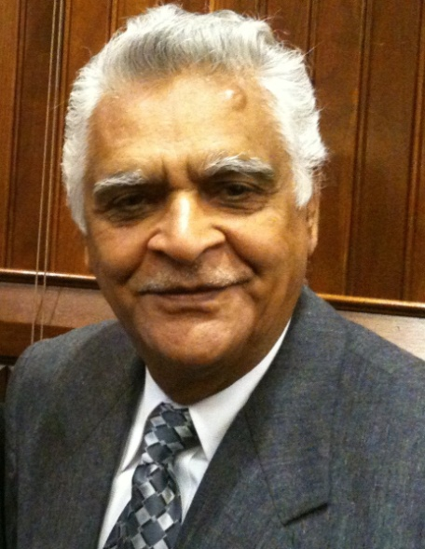
Suresh Sharma Chairman
IAICC Connecticut State Chapter
Publisher of PG. BETTER LIVING online Magazine. it is devoted to bring our Indian ethos which are tailored for the western living style of the adults, young and children as they seek to meet their personal, political, social, cultural, spiritual, health, financial and physical needs.
Creator of Facebook page Understanding for Global Peace. This page is for those who seek the solution to peace threatening and deteriorating global situation and are thinking what would be a more persuasive message about global peace?
Founder and Chairman of Milan Cultural Association (An association of people from India living in USA) is a 100% Voluntary driven non-profit, 501 (C)(3) association of people from India living in United States with chapters and membership across the United States of America pursuing participative mission of sharing and caring the social, civic, economic and public affairs of United States of America and India.
Here we celebrate the traditional art, culture and values of India to foster constructive relationships between individual, communities and institutions to build an environment of exploration, collaboration and celebration of the diverse cultural communities. in order to build bridges of mutual understanding, interest and trust.

