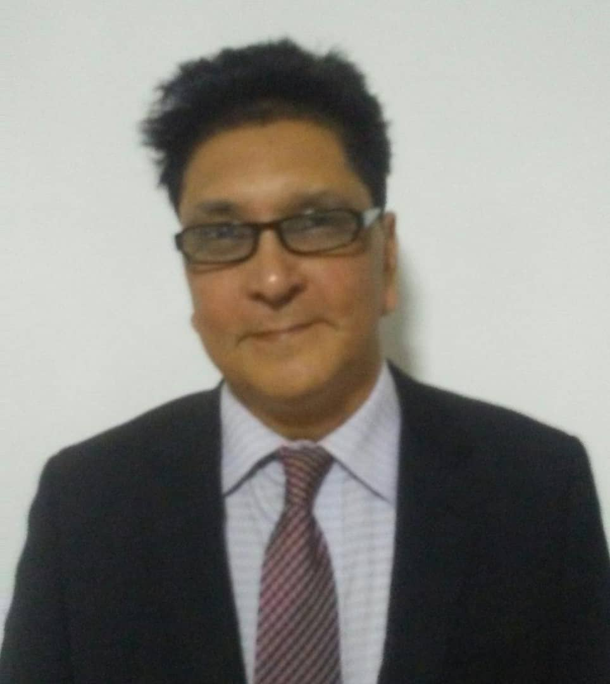

Chandan Bandopadhyay
Republic of Guinea West Africa Regional Office

Mr. Bando started his career as an Engineer with Lockheed Martin (USA), the maker of F-16 fighter jets. Later he joined Houghton Mifflin Company – Harcourt (USA) one of the most prestigious Media Houses of America. There after he worked for Vivendi Universal (USA), the global media house, in their business development as a senior executive.

Later he joined as the CEO of Media house in India (Mumbai), producing television programs for India and abroad. Mr. Bando started his media house to produce TV programs. He partnered with various international media houses in their operations in Indonesia, Malaysia, East Africa and Russia.

Mr. Bando served as the CEO for Sahara Samay News Network, one of the reputed news networks in India. He supervised all important aspects of the network such as News broadcasting, Finance, Marketing, Legal, Technical etc.

Mr. Bandorepresented Prestigious England’s LORDS, Marylebone Cricket Club – MCC, to initiate cricket academies in India. He introduced MCC to some of the renowned business hallmarks in India – Tata, Birla, Ruia (Essar-Vodafone), Sahara etc.

Apart from playing various executive designations, he ran his business operations by establishing offices in Mumbai, New Delhi, Chandigarh, Kolkata, Pune, Bali(Indonesia), Addis Ababa(Ethiopia), Boston(USA), Moscow(Russia), Bamako(Mali), Conakry (Guinea) etc.

Mr. Bando has set up companies in West and East Africa. He is currently setting up distribution network for various commodities such as Off Grid Hybrid Power Solutionsand Electronic equipment in various countries in Africa.
Mr. Chandan Bandostudied Business Management and computer science from one Northeastern University, Boston.

