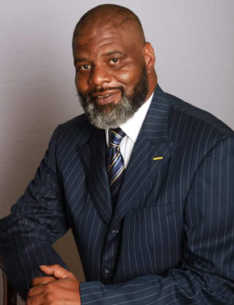
Terrance X. Johnson
CEO/Founder of TCJ AeroTech, LLC
A Drone Technology R&D Company based in Atlanta, GA

Executive Biography
Terrance X. Johnson, CEO and Founder of TCJ AeroTech, LLC; a drone technology, research and development company, is a man of many financial business talents and gifts. There is a relatively small segment of the population of leaders in the business world that are able to build relationships, trust, and rapport with other influential leaders, as well as to commission the proper alliances and make viable connections between peoplein creating partnerships and motivating all to “get things done”.
Terrance X. Johnson is one of those people, and “getting things done” and driving results is what he is all about. With much enthusiasm, focus and genuine compassion, Terrance radiates a sincere passion for developing and delivering value, benefits, and high-yielding synergistic returns to his customers and business counterparts alike.
Mr. Johnson is a true entrepreneur with over twenty years of Executive Management experience to his credit. Formerly, an executive with ABC/Walt Disney Corporation and Magic Johnson Enterprises, he also served as former Secretary of the Georgia Restaurant Council, former Vice-President of the Georgia Restaurant & Hotel Association and served on the Board of Directors for the Committee of Governmental Affairs for the State of Georgia.
Mr. Johnson’s vision is to assert a new way of life, creating global change through technological innovation, and aligning minority consumers (which represent $1 Trillion in spending in the U.S.) with the primary focus being the EasternCoast of the United States where the stage is set for new technology emergence in the drone industry.
Mr. Johnson is an FAA Certified Pilot with over 20 years of flight experience. And, as the first African American drone company on the East Coast, Mr. Johnson is looking to partner TCJ AeroTech, LLC with individuals who share the common vision to change the world, creating a global transformation of life and living for all humanity over the next generation and generations to come.
In addition to his many accomplishments, Mr. Johnson attended MorganStateUniversity and is a Veteran of the United States Military. He resides in Atlanta, GA with his wife of 24 years. He is a devoted Husband, Father and Grandfather.
TCJ AeroTech, LLC
“There’s no place to go, but up.”

