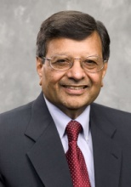
Dr. Jagdish (Jag) Sheth
Advisory Board Member [USIACC SE Atlanta Region]

Professor Jagdish Sheth is a renowned scholar and internationally recognized thought leader. He has published more than 300 research papers and more than 30 books on various disciplines and topics. His insights on global competition, strategic thinking, geopolitics, and emerging markets are considered revolutionary.

As a thought leader, Professor Sheth has made hundreds of presentations to business leaders, academic scholars, and public policy makers from around the world. He is frequently quoted and interviewed by Fortune, Financial Times, The Economic Times, The New York Times, and The Wall Street Journal. He is also a regular guest and frequent commenter for major news networks: BBC, CNBC India, and CNN. Professor Sheth’s timely advice aids business leaders, and policymakers looking to develop long-term strategies for positioning for the future.

