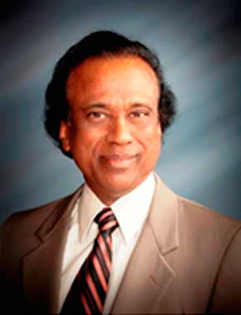
Dr. Girish Panicker
Advisory Board Member [USIACC SE Atlanta Region]

Dr. Girish Kumar Panicker, an authority on C-factor (cover and management) research and an internationally renowned agricultural scientist, is a professor and director of Conservation Research at Alcorn State University, Mississippi. A native of India, Dr. Panicker holds B.S. in Agriculture, M.S. in agronomy and Ph.D. in horticulture. He has worked largely in conservation field on three continents, Asia, Africa and North America. His federally funded research center has the world’s largest C-factor (cover and management) databank on horticultural crops, with work done on 40 crops at an investment of more than $6.5 million. The information generated addresses erosion prediction, nutrient management and conservation planning as well as prevention of soil erosion and climate change. In collaboration with the U.S. Army and USDA, he has succeeded in producing a slow-release, and environmental friendly organic compost from animal waste. He made breakthrough in organic blueberry research by increasing Vitamin C and anthocyanins. Now, his organic Blueberries, produced under worm castings, is 83 percent higher vitamin C content compared to blueberries available in the open market.
Dr. Panicker has travelled extensively around the globe and represented the U.S. several times at international conferences. His speeches, delivered at international conferences, are being podcasted globally by the American Society for Horticultural Science (ASHS), International Society for Horticultural Science (ISHS), Belgium, USDA, eOrganic, and eXtension. With numerous publications to his credit, he has been a member of several national and international agricultural societies. As a member of the National Sustainable Agriculture Coalition (NASC), Washington, D.C., he is deeply involved in providing recommendations for policy makers on sustainable agriculture. He has served as chairman of the National Committee for Publication Awards of the ASHS and chairman of the division of Agriculture of Mississippi Academy of Sciences. He serves as director board member of the Mississippi Sustainable Agriculture Network (MSAN), International Women’s Think Tank (IWTT), and Science Advisory Board for the Organic Center, Washington, D.C.

