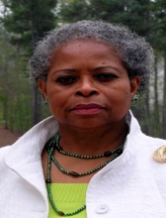
Ms. Brenda Morant
Special Assistant to the National Chairman & Co-Chair [USIACC SE Atlanta Region]

Brenda Morant is a pioneer and forerunner for the empowerment of women and girls. She serves as President of the International Women's Think Tank, an organization focused on promoting research, critical thinking and innovative solutions on issues related to women and girls. Major research includes “The Third Billion” and women’s reimaging of the global economy.

Working with the Aerotropolis Atlanta Alliance, public school systems and a broad
range of trade associations, Fortune 500’s, governments and NGO’s, Brenda guides the
long-term strategic vision of clients and helps identify growth opportunities as the
organization continues to innovate ways to increase sustainable development.

